**SDF LAB_W-1**

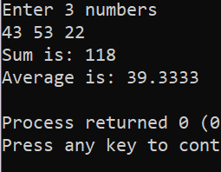Q1. #include <iostream>

using namespace std;

int main()

{

int a,b,c;

float f;

cout << "Enter 3 numbers" << endl;

cin >> a >> b >> c ;

f=(float)(a+b+c)/3;

cout << "Sum is: "<< a+b+c << endl;

cout << "Average is: "<< f << endl;

return 0;

}

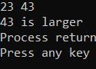Q2. #include <iostream>

using namespace std;

int main()

{

int a,b;

cin>>a>>b;

if(a>b)

cout<<a<<" is larger";

else if(b>a)

cout<<b<<" is larger";

else cout<<"both are equal";

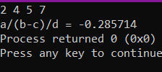}

Q3. #include <iostream>

using namespace std;

int main()

{

float a,b,c,d;

float x;

cin>>a>>b>>c>>d;

if(b-c!=0)

{

x=a/(b-c)/d;

cout<<"a/(b-c)/d = "<<x;

}

else cout<<"Cannot divide by 0. Try again with different input";

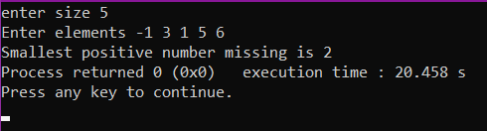}

Q4. #include<iostream>

using namespace std;

int main()

{

int s,c=0;

cout<<"enter size ";

cin>>s;

int arr[s];

cout<<"Enter elements ";

for(int i=0;i<s;i++)

cin>>arr[i];

for(int i=1;i<=s+1;i++)

{

c=0;

for(int j=0;j<s;j++)

{

if(arr[j]==i)

c++;

}

if(c==0)

{

cout<<"Smallest positive number missing is "<<i;

break;

}

}

}

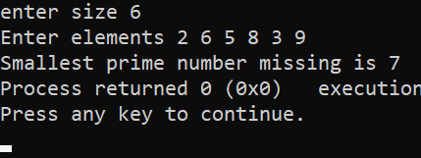Q5. #include<iostream>

using namespace std;

int main()

{

int N=100,a=0;

int s,c=0;

cout<<"enter size ";

cin>>s;

int arr[s];

cout<<"Enter elements ";

for(int i=0;i<s;i++)

cin>>arr[i];

int n,i = 3, count,arr1[s];

if(s >= 1)

{

arr1[a]=2;

a++;

}

for(count = 2; count <= s; i++)

{

// iteration to check c is prime or not

for(c = 2; c < i; c++)

{

if(i%c == 0)

break;

}

if(c == i) // c is prime

{

arr1[a]=i;

a++;

count++;

}

}

int max=arr[0];

for(int i=0;i<s;i++)

{

if(arr[i]>max)

max=arr[i];

}

for(int i=0;i<s+1;i++)

{

c=0;

for(int j=0;j<s;j++)

{

if(arr[j]==arr1[i])

c++;

}

if(c==0 && arr1[i]<max)

{

cout<<"Smallest prime number missing is "<<arr1[i];

exit(0);

}

}

cout<<"No prime number is missing ";

}

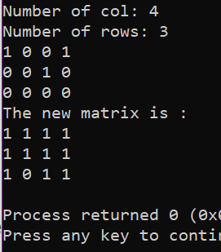Q6. #include<iostream>

using namespace std;

int main()

{

int r,c;

cout<<"Number of col: ";

cin>>c;

cout<<"Number of rows: ";

cin>>r;

int arr[r][c],arr1[r][c];

for(int i=0;i<r;i++)

{

for(int j=0;j<c;j++)

{

cin>>arr[i][j];

}

}

for(int i=0;i<r;i++)

{

for(int j=0;j<c;j++)

{

arr1[i][j]=0;

}

}

for(int i=0;i<r;i++)

{

for(int j=0;j<c;j++)

{

if(arr[i][j]==1)

{

for(int k=0;k<c;k++)

{

arr1[i][k]=1;

}

for(int k=0;k<r;k++)

{

arr1[k][j]=1;

}

}

}

}

cout<<"The new matrix is :"<<endl;

for(int i=0;i<r;i++)

{

for(int j=0;j<c;j++)

{

cout<<arr1[i][j]<<" ";

}

cout<<endl;

}

return 0;

}

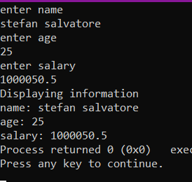Q7.

#include<iostream>

#include<iomanip>

using namespace std;

struct Data

{

char name[20];

int age;

float salary;

};

int main()

{

struct Data a;

cout<<"enter name"<<endl;

gets(a.name);

cout<<"enter age"<<endl;

cin>>a.age;

cout<<"enter salary"<<endl;

cin>>a.salary;

cout<<"Displaying information"<<endl;

cout<<"name: ";

puts(a.name);

cout<<"age: "<<a.age<<endl<<"salary: "<<fixed<<setprecision(1)<<a.salary;

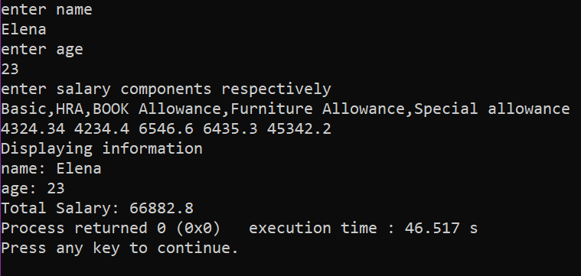}

Q8. #include<iostream>

#include<iomanip>

using namespace std;

struct Data

{

char name[20];

int age;

float B,BA,H,FA,SA,sal;

};

int main()

{

struct Data a;

cout<<"enter name"<<endl;

gets(a.name);

cout<<"enter age"<<endl;

cin>>a.age;

cout<<"enter salary components respectively"<<endl<<"Basic,HRA,BOOK Allowance,Furniture Allowance,Special allowance"<<endl;;

cin>>a.B>>a.H>>a.BA>>a.FA>>a.SA;

a.sal=a.B+a.H+a.BA+a.FA+a.SA;

cout<<"Displaying information"<<endl;

cout<<"name: ";

puts(a.name);

cout<<"age: "<<a.age<<endl<<"Total Salary: "<<fixed<<setprecision(1)<<a.sal;

}

Q9.

#include<iostream>

#include<iomanip>

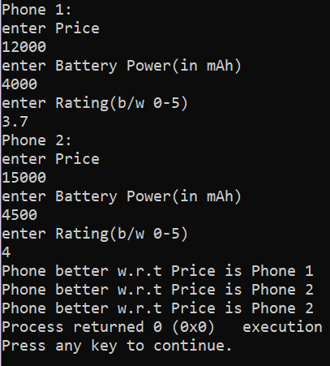

using namespace std;

struct Ph

{

int P,B;

float R;

};

int main()

{

struct Ph a,b;

cout<<"Phone 1:"<<endl;

cout<<"enter Price"<<endl;

cin>>a.P;

cout<<"enter Battery Power(in mAh)"<<endl;

cin>>a.B;

cout<<"enter Rating(b/w 0-5)"<<endl;

cin>>a.R;

cout<<"Phone 2:"<<endl;

cout<<"enter Price"<<endl;

cin>>b.P;

cout<<"enter Battery Power(in mAh)"<<endl;

cin>>b.B;

cout<<"enter Rating(b/w 0-5)"<<endl;

cin>>b.R;

if(a.P>b.P)

cout<<"Phone better w.r.t Price is Phone 2"<<endl;

else cout<<"Phone better w.r.t Price is Phone 1"<<endl;

if(a.B>b.B)

cout<<"Phone better w.r.t Price is Phone 1"<<endl;

else cout<<"Phone better w.r.t Price is Phone 2"<<endl;

if(a.R>b.R)

cout<<"Phone better w.r.t Price is Phone 1";

else cout<<"Phone better w.r.t Price is Phone 2";

}

Q9.

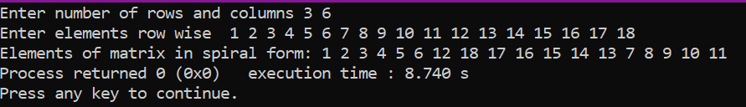

#include<iostream>

#include<iomanip>

using namespace std;

int main()

{

int r;int c;

cout<<"Enter number of rows and columns ";

cin>>r>>c;

int arr[r][c];

cout<<"Enter elements row wise ";

for(int i=0;i<r;i++)

{

for(int j=0;j<c;j++)

{

cin>>arr[i][j];

}

}

int k,temp=1,max=r*c;

cout<<"Elements of matrix in spiral form: ";

for(int i=0;i<r/2+1;i++)

{

if(temp<=max){

k=0+i;

for(int j=0+i;j<=c-i-1;j++)

{

cout<<arr[k][j]<<" ";

temp++;

}

}

if(temp<=max){

k=c-i-1;

for(int j=0+i+1;j<r-i;j++)

{

cout<<arr[j][k]<<" ";

temp++;

}

}

if(temp<=max){

k=r-i-1;

for(int j=c-i-2 ;j>0+i-1;j--)

{

cout<<arr[k][j]<<" ";

temp++;

}

}

if(temp<=max){

k=0+i;

for(int j=r-i-2;j>0+i;j--)

{

cout<<arr[j][k]<<" ";

temp++;

}

}

}

}